Assignment – 4

|  |  |
| --- | --- |
| Assignment Date | 22 October 2022 |
| Student Name | Kamal anand J |
| Student Roll Number | 311019104031 |
| Maximum Marks | 2 marks |

# Question-1:

Pull an Image from docker hub and run it in docker playground.

# Solution:

* Pull an image *uifd/ui-for-docker* from the docker hub
* This image is used for viewing and managing the docker engine
* Use docker pull image_name and docker run -it image_name commands to ● Run the above image in the Docker Playground

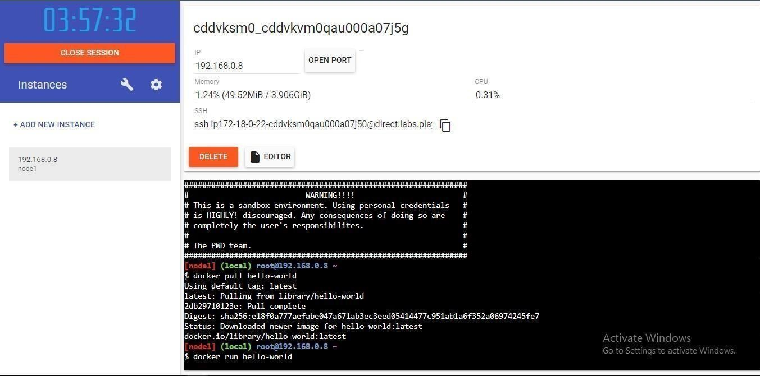

# Question-2:

Create a docker file for the job portal application and deploy it in Docker desktop application.

# Solution:

* Create a docker file for build and deploy flask app.
* Use docker build -t image_name. In the current directory to start building the
* docker image and deploy in our local docker
* Use docker run -p 5000:5000 image_name to run in local system

# CODE

FROM ubuntu/apache2 FROM python

COPY ./requirements.txt /flaskApp/requirements.txt WORKDIR /flaskApp

RUN pip install -r requirements.txt COPY . /flaskApp

ENTRYPOINT [ "python" ]

CMD ["app.py" ]

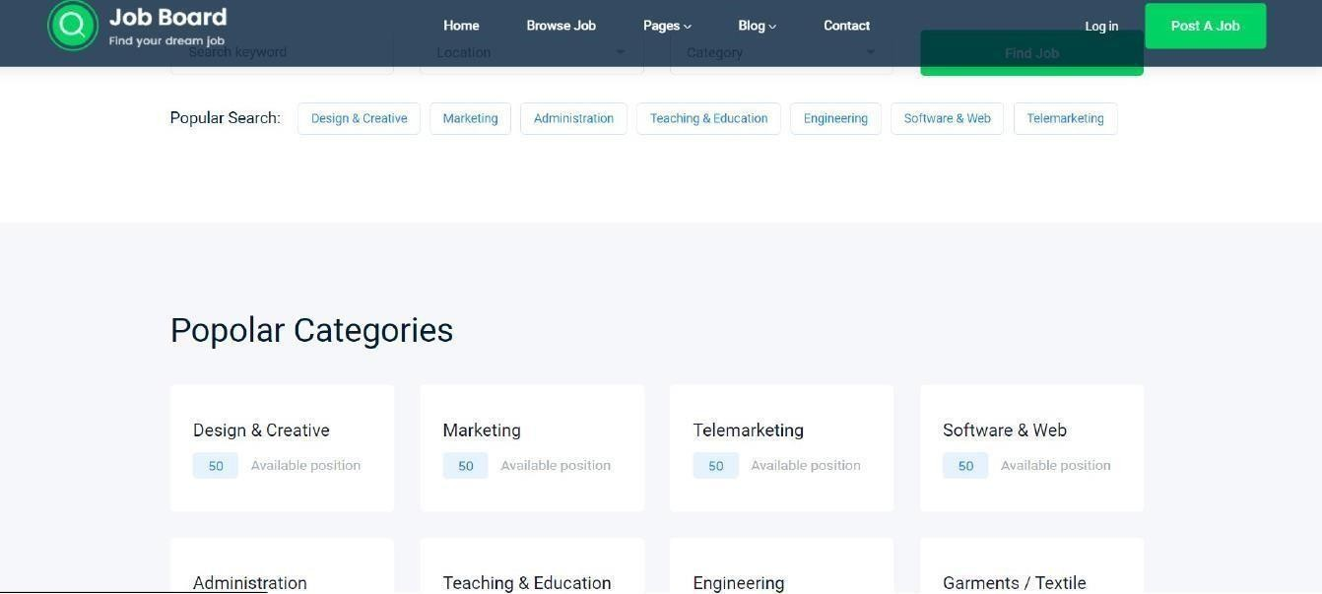

# Question-3:

Create a IBM container registry and deploy hello world app or job portal app.

# Solution:

* + Log into IBM cloud
  + Create a container registry
  + Using IBM Cloud CLI, install the container registry plugin in our system
  + Push our docker image into the created container registry using docker push So, our job portal app is deployed in the IBM container registry

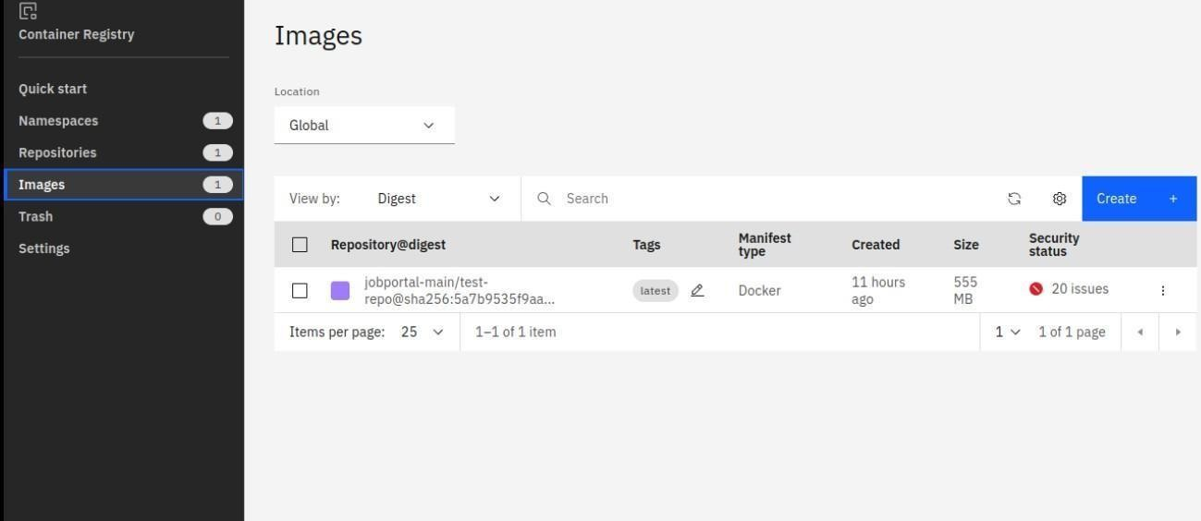

OUTPUT:

“HELLO WORLD”

# Question-4:

Create a Kubernetes cluster in IBM cloud and deploy hello world image or job portal image and also expose the same app to run in node port.

# Solution:

* Log into IBM cloud
* Create a kubernete
* Using IBM Cloud CLI, install the ks plugin in our system
* Create a cluster in the kubernetes
* Now, go to the kubernetes dashboard where we need to create a service based on a ● yml file (given below)
* In that file, we have to mention *which image we are going to use* and the *app name*
* Take the public IP address and Nodeport since we exposed the *flask app in nodeport*
* Finally, we got the url address where our flask app is hosted

# CODE:

apiVersion: v1 kind: Service metadata: name: job-portal-app spec: selector:

app: job-portal-app ports: - port: 5000 type: NodePort

---

apiVersion: apps/v1 kind: Deployment

metadata:

name: job-portal-app labels:

app: job-portal-app spec: selector: matchLabels: app: job-portal-app replicas: 1

template: metadata: labels:

app: job-portal-app spec: containers:

* name: job-portal-app image: image_name ports:
* containerPort: 5000

env:

* name: DISABLE_WEB_APP

value: "false"

